Memo

|  |  |
| --- | --- |
| To: | Troy Scevers |
| From: | Nathan Wiley |
| Date: | October 14, 2022 |
| Re: | Memo 2 |
|  |  |

This week I have spent most of my time learning how to use Autodesk Inventor. I believe it will be worthwhile because I need a good foundation for my embedded project to operate on, and it won’t function if I do not have a functional telescope to start with. I have designed the parts for the tube rings, base, and turntable and made blueprints for these parts with properly constrained dimensions. Once I know the dimensions of the motors and potential gear assembly, I will model them in Autodesk Inventor and create a functional 3D assembly to visualize everything before physically putting it all together. I have also purchased a 4’x8’ sheet of 23/32” Sande plywood that I am cutting tomorrow. I have mapped all of my parts with their dimensions on to an equal sized object in Inventor to ensure that they would all fit. In inventor I have logged 5.5 hours this week.

I spent an hour at Home Depot purchasing materials and asking the employees for recommendations for materials and paint. I found that Sande plywood is much better suited for outdoor projects as it resists water damage and warping significantly better than birch plywood or the regular ACX or CDX sheets. I also purchased professional primer, white, and black paint to use on the wood. I still need to purchase varnish as suggested by the employees and several forum members of “cloudy nights” – which is a telescope and astrophotography forum with many DIY projects on file.

In all, this week I’ve worked 7 hours including the time writing this memo.

Next week I plan on cutting the parts out of the plywood, choosing motors and gears, designing a method of mounting the vertical axel with motor and gear placement in mind, assembly of tube rings, and painting the tube and wood parts.

**Below is the detailed schedule for this term with completed items in green:**



**Below are screenshots from Autodesk Inventor of the telescope assembly and how the parts fit on the 4’x8’ sheet of plywood:**

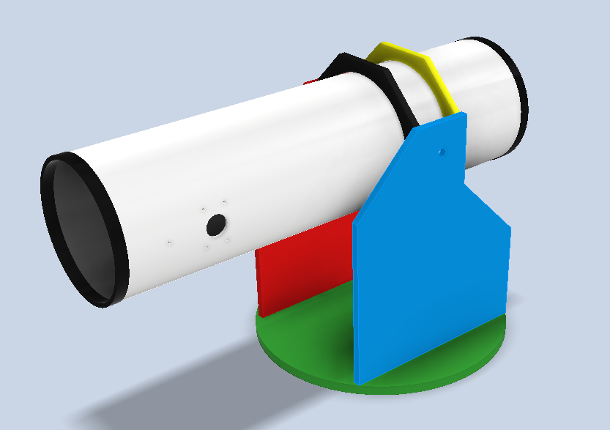

**The following pages are the drawings of each part with annotations of the dimensions:**

